# CSE4001 - Parallel and Distributed Computing

# Lab 21+22

# Lab Task1

# Submitted by: Alokam Nikhitha

# Reg No:19BCE2555

# VECTOR ADDITION

# CODE:

#include <stdlib.h> //malloc and free

#include <stdio.h> //printf

#include <omp.h> //OpenMP

// Very small values for this simple illustrative example

#define ARRAY_SIZE 8 //Size of arrays whose elements will be added together.

#define NUM_THREADS 4 //Number of threads to use for vector addition.

/*

* Classic vector addition using openMP default data decomposition.

*

* Compile using gcc like this:

* gcc -o va-omp-simple VA-OMP-simple.c -fopenmp

*

* Execute:

* ./va-omp-simple

*/

int main (int argc, char *argv[])

{

// elements of arrays a and b will be added

// and placed in array c

int * a;

int * b;

int * c;

int n = ARRAY_SIZE; // number of array elements

int n_per_thread; // elements per thread

int total_threads = NUM_THREADS; // number of threads to use

int i; // loop index

// allocate spce for the arrays

a = (int *) malloc(sizeof(int)*n);

b = (int *) malloc(sizeof(int)*n);

c = (int *) malloc(sizeof(int)*n);

// initialize arrays a and b with consecutive integer values

// as a simple example

for(i=0; i<n; i++) {

a[i] = 3*i;

}

for(i=0; i<n; i++) {

b[i] = 2*i;

}

// Additional work to set the number of threads.

// We hard-code to 4 for illustration purposes only.

omp_set_num_threads(total_threads);

// determine how many elements each process will work on

n_per_thread = n/total_threads;

// Compute the vector addition

// Here is where the 4 threads are specifically 'forked' to

// execute in parallel. This is directed by the pragma and

// thread forking is compiled into the resulting exacutable.

// Here we use a 'static schedule' so each thread works on

// a 2-element chunk of the original 8-element arrays.

#pragma omp parallel for shared(a, b, c) private(i) schedule(static, n_per_thread)

for(i=0; i<n; i++) {

c[i] = a[i]+b[i];

// Which thread am I? Show who works on what for this samll example

printf("Thread %d works on element%d\n", omp_get_thread_num(), i);

}

// Check for correctness (only plausible for small vector size)

// A test we would eventually leave out

printf("i\ta[i]\t+\tb[i]\t=\tc[i]\n");

for(i=0; i<n; i++) {

printf("%d\t%d\t\t%d\t\t%d\n", i, a[i], b[i], c[i]);

}

// clean up memory

free(a); free(b); free(c);

return 0;

}

# OUTPUT:

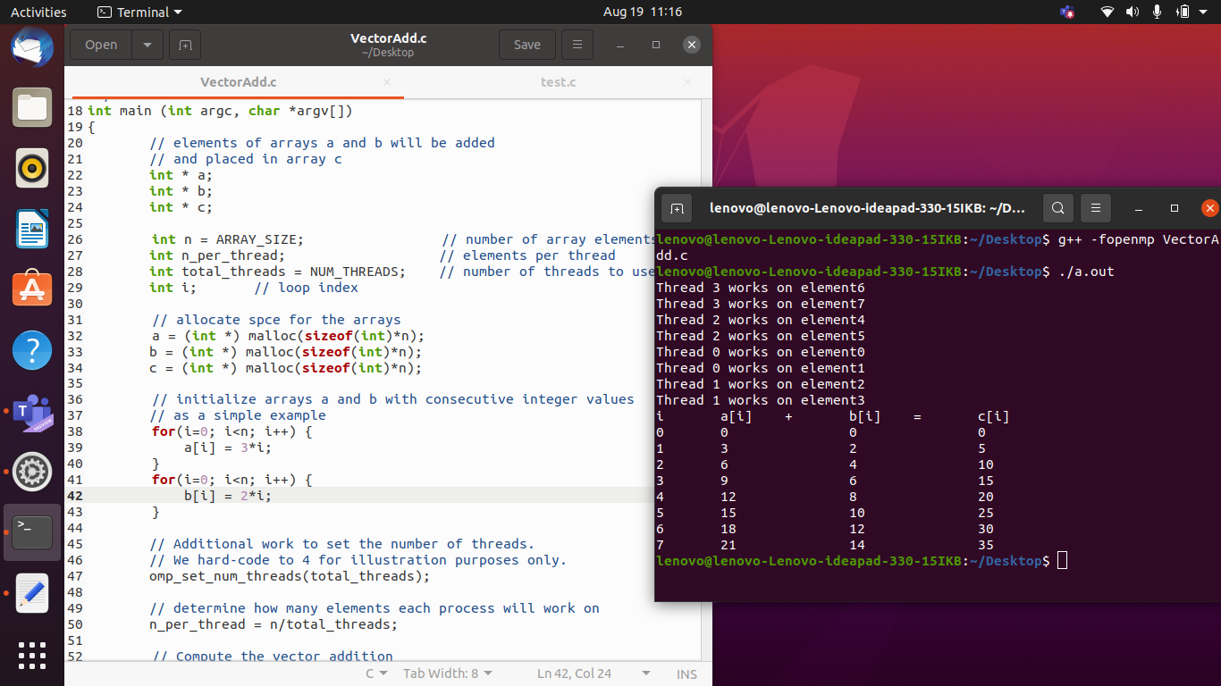

# TEST

# CODE:

#include<stdio.h>

#include<stdlib.h>

#include<omp.h>

int main(int argc,char *argv[]) {

double sum,a[256],b[256];

int i,n=256;

for(i=0;i<n;i++){

a[i]=i*1.5;

b[i]=i*3.0;

}

sum=0;

for(i=0;i<n;i++)

sum+=a[i] *b[i];

printf("a*b = %f\n",sum);

}

# OUTPUT:

# 

# SUMMATION CODE:

#include <stdio.h>

#include <stdlib.h>

#include <omp.h>

int main(int args, char *argv[]) {

int partial_Sum;

int total_Sum;

int i;

#pragma omp parallel private(partial_Sum) shared(total_Sum)

{

partial_Sum=0;

total_Sum=0;

#pragma omp

{

for(i=1;i<=500;i++)

{

partial_Sum += i;

}

}

#pragma omp critical

{

total_Sum += partial_Sum;

}

}

printf("Total Sum: %d\n", total_Sum);

return 0;

}

# OUTPUT:

